## Quiz-3

|  |  |
| --- | --- |
| Answer **ALL** the questions | Total marks - 20 |

**\*** Always round off your results to two places after the decimal point whenever necessary. For example, 12.34556 becomes 12.35, and 12.34456 becomes 12.34.

1. Compute DFT of the following function: 𝑓(𝑥) = 5 𝛿(𝑥) 𝑓𝑜𝑟 𝑥 = 0, 1, 2 𝑎𝑛𝑑 3 where 𝛿(𝑥) is *unit impulse function.* Fill the following table. **(0.5 x 8 = 4 marks)**

DFT of 𝑓(𝑥)

|  |  |  |
| --- | --- | --- |
| 𝑥 | 𝑓(𝑥) | 𝐹(𝑢) |
| 0 | 5 | 5 |
| 1 | 0 | 5 |
| 2 | 0 | 5 |
| 3 | 0 | 5 |

**Hint: Unit impulse is 1 when x=0 and it is 0 elsewhere.**

1. Compute DFT for the following 𝑓(𝑥) and fill in the table below**: (0.5 x 16 = 8 marks)**

𝑓(𝑥) = [ 𝑗, 0, 𝑗, 1].

|  |  |  |  |
| --- | --- | --- | --- |
| 𝑭(𝒖) | Magnitude | Phase | Power spectrum |
| F (0) =1+ 2j | Sqrt (2^2 + 1^2) = Sqrt (5) = 2.24 (2d.p) | Tan^-1(2/1) = 1.11 (2d.p) | 2^2 + 1^2 = 5 |
| F (1) = j | Sqrt (1^2 + 0^2) = Sqrt (1) = 1 | Tan^-1(1/0) = 0 | 1^2 + 0^2 = 1 |
| F (2) = – 1 + 2j | Sqrt (2^2 + (-1) ^2) = Sqrt (5) = 2.24 (2d.p) | Tan^-1(2/(-1)) = -1.11 (2d.p) | 2^2 + (-1) ^2 = 5 |
| F (3) = - j | Sqrt ((-1) ^2 + 0^2) = Sqrt (1) = 1 | Tan^-1((-1)/0) = 0 | (-1) ^2 + 0^2 = 1 |

1. Compute Fourier Transform for the following f(x) using FFT method. Show all the stages, intermediate results, and the final results in the Butterfly approach clearly. Write your F(u) in two decimal places. **(1 x 8 = 8 marks)**

|  |  |  |  |  |  |  |  |  |
| --- | --- | --- | --- | --- | --- | --- | --- | --- |
| x | 0 | 1 | 2 | 3 | 4 | 5 | 6 | 7 |
| f(x) | 5 | 4 | 3 | 2 | 1 | 0 | 4 | 6 |
| F(u) | 25 | 9.60 + j | -1 + 4j | -1.60 - j | 1 | -1.60 + j | -1 – 4j | 9.60 - j |

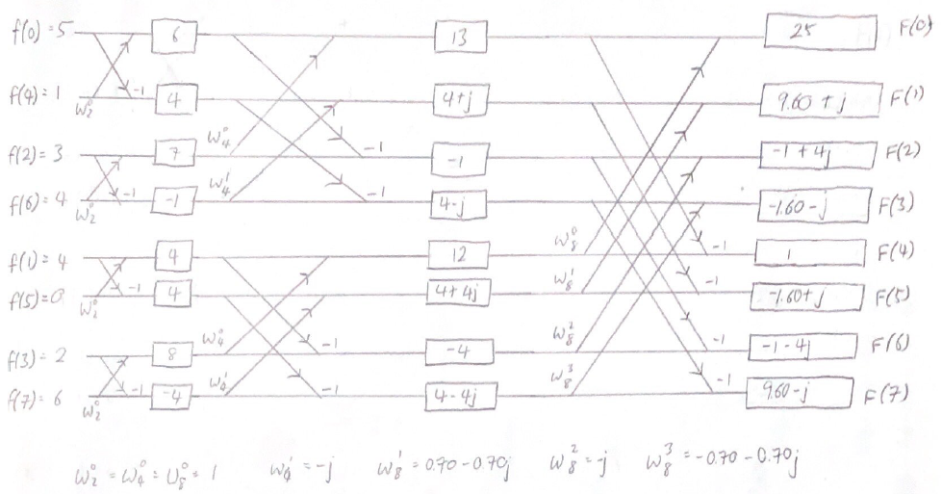

Write your Butterfly approach diagram here

# --------------------------Rough Work Sheet-------------------------------

**(Do not detach it)**

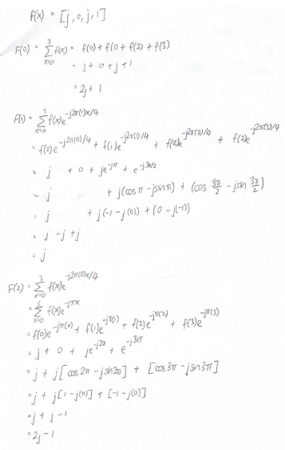 Q1. Q2.

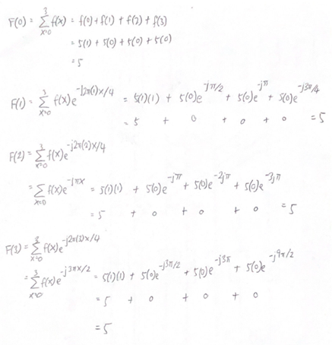

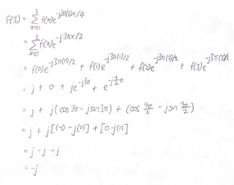

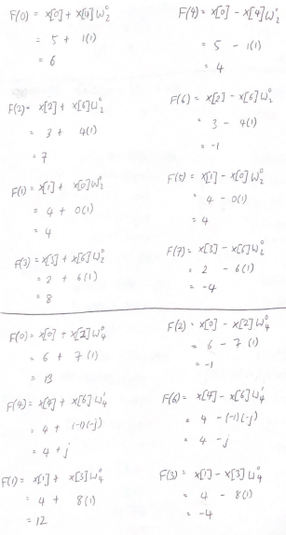Q3.

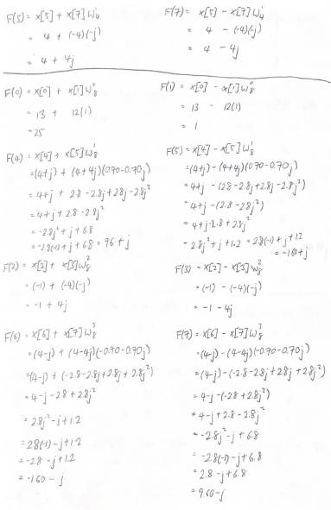

# --------------------------Rough Work Sheet-------------------------------

## (Do not detach it)